Game Design Document

Fill up the following document

1. Write the title of your project.

Flappy bomb

1. What is the goal of the game?

To get a high school

1. Write a brief story of your game.

Well theres an angry bird, that wants to get to the other side to get his eggs back

1. Which are the playing characters of this game?

* Playing characters are the ones who respond to the user based on the input from the user.
* Cars, monkeys, dinos, wizards, etc., are the playing characters in the game.

|  |  |  |
| --- | --- | --- |
| Number | Character Name | What can this character do? |
| 1 | bomb | He can flap up and down |
| 2 |  |  |
| 3 |  |  |
| 4 |  |  |
| 5 |  |  |
| 6 |  |  |
| 7 |  |  |
| 8 |  |  |

1. Which are the Non-Playing Characters of this game?

* Non-Playing characters are the ones that don't have an action or behavior when the user interacts with the game.
* Hurdles, stones, bananas, coins, etc., are non-playing characters in the game.

|  |  |  |
| --- | --- | --- |
| Number | Character Name | What can this character do? |
| 1 | pipe | It spawns randomly and kills the player |
| 2 | ground | It’s the ground and kills the player |
| 3 |  |  |
| 4 |  |  |
| 5 |  |  |
| 6 |  |  |
| 7 |  |  |
| 8 |  |  |

Draw your imagination of this game. What does this game look like?

* Draw the game either on your computer or on paper.
* Add images of the game scenes to show each of the playing and non-playing characters at least once

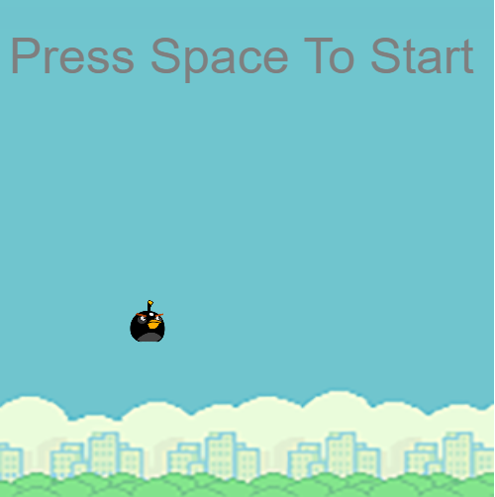.

How do you plan to make your game engaging?

It well get more and more difficult.